# NO SQL LAB-2

**Question**

(**Week9**)

Perform the following DB operations using MongoDB.

1. Create a collection by name Customers with the following attributes. Cust_id, Acc_Bal, Acc_Type

2. Insert at least 5 values into the table

3. Write a query to display those records whose total account balance is greater than 12000 of account type ‘Checking’ for each customer_id.

4. Determine Minimum and Maximum account balance for each customer_id.

5. Export the created collection into local file system

6. Drop the table

7. Import a given csv dataset from local file system into mongodb

collection.

**Create database**

db.createCollection("Customer");



**create table**

db.Customer.insertMany([{custid: 1, acc_bal:10000, acc_type: "Saving"}, {custid: 1, acc_bal:20000, acc_type: "Checking"}, {custid: 3, acc_bal:50000, acc_type: "Checking"}, {custid: 4, acc_bal:10000, acc_type: "Saving"}, {custid: 5, acc_bal:2000, acc_type: "Checking"}]);

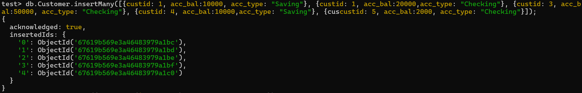

**Queries**

1. . Write a query to display those records whose total account balance is greater than 12000 of account type ‘Checking’ for each customer_id.

db.Customer.find({acc_bal: {$gt: 12000}, acc_type:"Checking"});

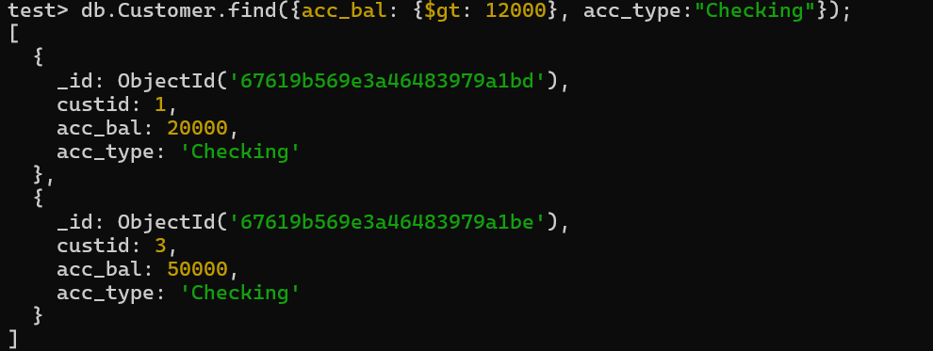

2. Determine Minimum and Maximum account balance for each customer_id.

db.Customer.aggregate([{$group:{_id:"$custid", minBal:{$min:"$acc_bal"}, maxBal: {$max:"$acc_bal"}}}]);

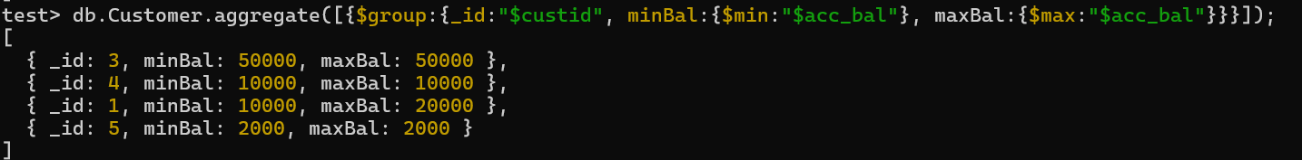

3. Export the created table into local file system

mongoexport mongodb+srv://204:<password>@cluster0.xbmgopf.mongodb.net/test

--collection=Student – out C:\Users\college\Documents\test.Customer.json

4. Drop the table

db.Customer.drop();

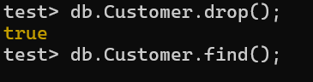

5. Import a given csv dataset from local file system into mongodb collection.

mongoimport mongodb+srv://204:<password>@cluster0.xbmgopf.mongodb.net/test

--collection=Student –type json –file C:\Users\college\Documents\test.Customer.json

db.Customer.find();

